World Happiness Review

Mary Manz\*

MATH637 - Math Techniques in Data Science

University of Delaware

Newark, DE 19716

April 30, 2021

1. Introduction

Imagine a world full of happy people; could that ever be possible? In June 2011, the United Nations General Assembly passed the Bhutanese Resolution, which focuses on giving “more importance to happiness and well-being in determining how to achieve and measure social and economic development” [1]. In April 2012, the United Nations had a meeting regarding the Bhutanese Resolution, during which the first World Happiness Report was shared. The meeting was chaired by the Prime Minister of Bhutan, Jigmi Y. Thinley, and American economist, Jeffrey D. Sachs. (It is worth noting that Bhutan, a small and mostly Buddhist country (less than 1 million in population) between India and China, is known for its peacefulness [2]). There has been a world happiness report for almost each year following its debut in 2012.

The main source of data for the happiness reports comes from the Gallup World Poll [1]. The poll is conducted via telephone for most countries, and in-person for developing countries. Over 150 countries are covered (only 195 countries in the world). All poll respondents are over the age of 14, and the number of surveys conducted in each country, depending on population, are around 1,000 to 2,000 [3]. According to the World Happiness Report, how a country ranks is based on a single question from the Gallup World Poll: how would you rate your current life? The scale used is called the Cantril ladder, which goes from zero to ten with zero representing the worst possible life and ten the best. The rankings use data from the past two years. The world happiness report tries to explain why countries ranked the way that they did, using statistics based on six factors: levels of GDP, life expectancy, generosity, social support, freedom, and corruption; however, these estimates have no impact on the actual rankings.

I would like to think that due to advancements in medicine and societies becoming more peaceful that happiness levels for most countries have generally increased. I am also curious about the overall happiness of the world vs. by country. In this report, Section 2 discusses how happiness levels are trending by country; Section 3 discusses happiness levels in terms of total population, and Section 4 contains concluding remarks.

1. How has the happiness of people in different countries fluctuated over the last 5 years?

Now that several years have passed since the first World Happiness Report was released, we can see how the scores amongst the tracked countries have varied over the years.

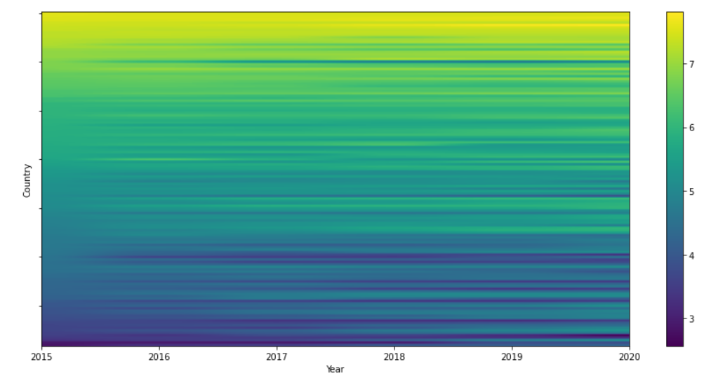

Figure 1 – Heatmap of happiness scores by country from 2015-2020. Lower scores are in dark blue and higher scores are in yellow. Each row represents a single country, and the color of the row, moving to the right, represents that country’s happiness score each year since 2015.

According to Figure 1, it is hard to tell if there are any major changes in happiness scores amongst any countries. It appears the happiness scores of countries has remained consistent over the years for each country. To get a better idea about whether this is the case, I used the k-means clustering method, which groups countries with similarly trending happiness scores. I used the elbow method to determine that six is the optimal number of groups to apply the k-means clustering method to.

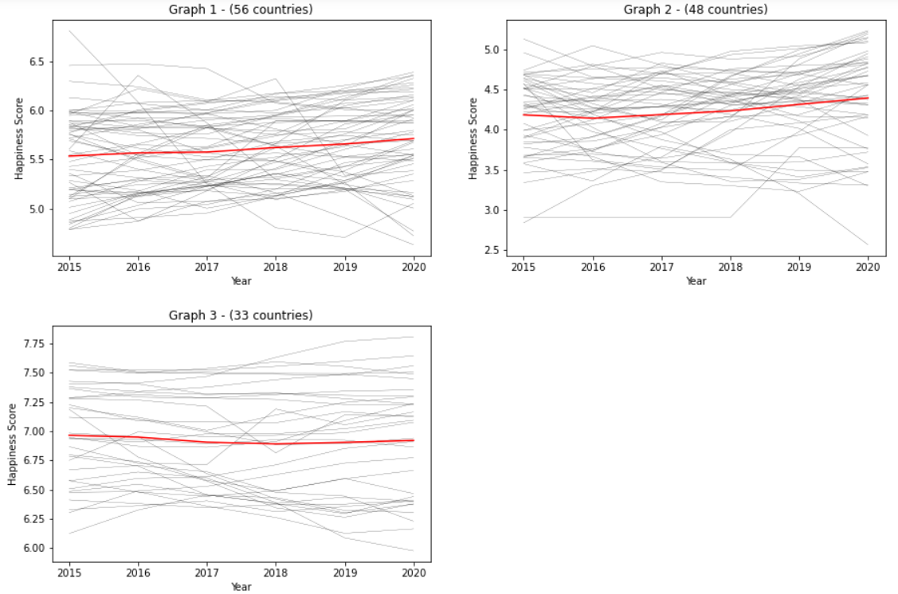

Figure 2 – The red line in each graph represents the cluster center, or the average trending line of the happiness scores over time amongst the countries included in that group. The title of each graph indicates the number of countries included in that group. The grey lines represent the happiness scores of each country.

Based on the above, it appears as though the happiness scores for most countries have not fluctuated by a substantial amount over the years. The cluster center in Graph 3 shows hardly a change at all. The cluster centers for Graphs 1 and 2 show a slight increase in scores. However, it is possible that a different number of groups or clustering method would more accurately portray the trends amongst countries.

Overall, it seems as though the happiness level of people across the world has not changed much over the past five years, but for most countries there has generally been a slight increase. Based on Figure 1 and Figure 2, countries with the highest happiness scores, in most cases, maintain these scores over the five-year period of 2015-2020. Though it is important to keep in mind that the data reviewed does not include every single country in the world. There are close to 200 countries in the world, and the data analyzed covers 137. Note: there were several countries included in the World Happiness Report for some years and not others; these countries were excluded from this analysis. Also, the data reviewed is sampled data, which of course is never 100% representative of the population. Further, the sampled data may not always include accurate happiness scores from individuals surveyed; for example, a person surveyed just after getting a bonus at work might respond with a happiness score higher than what they would respond with on most days.

1. How happy are most people in the world?

Focusing now on data from 2020, I was interested in happiness levels in terms of total population.

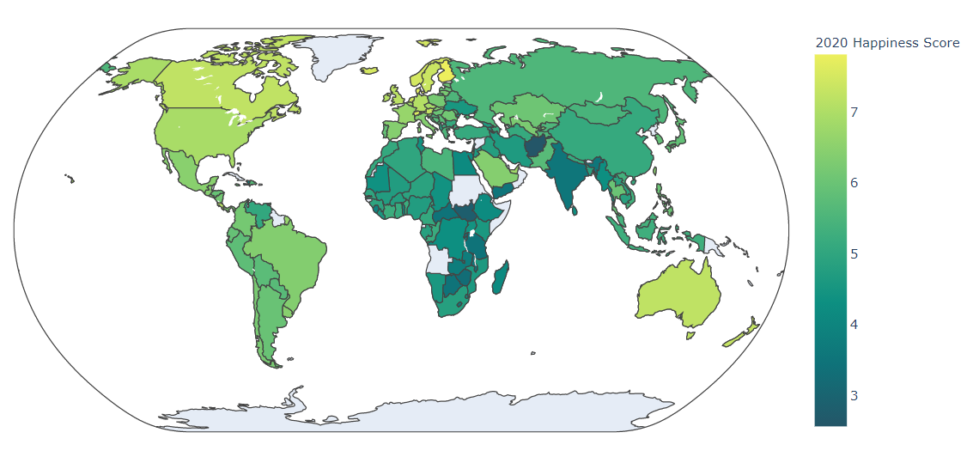

Figure 3 – Choropleth map of the world based on 2020 happiness scores. The shade of each country represents its 2020 happiness score; lower scores are in dark green and higher scores are in yellow. Countries shaded in grey were not included in the 2020 World Happiness Report.

As depicted above, Figure 3 gives a sense of how much of the world, at least geographically, is on the higher and lower end of the happiness scale for the year 2020. It appears the western side of the world is generally happier than the eastern side, except for Europe and Australia/New Zealand. It also looks as though, for the most part, Africa and Asia are not as happy as the rest of the world.

Given that certain parts of the world seem to have similar scores, I thought it was worth seeing how happiness levels compared across regions, taking total population into account. Since the data set for the 2020 world happiness report did not include the population of each country, I merged this data set with another data set containing populations for countries in 2020. The two data sets did not contain coverage for all the same countries; I did my analysis only for countries for which they did. A total of 142 countries were included in this analysis.

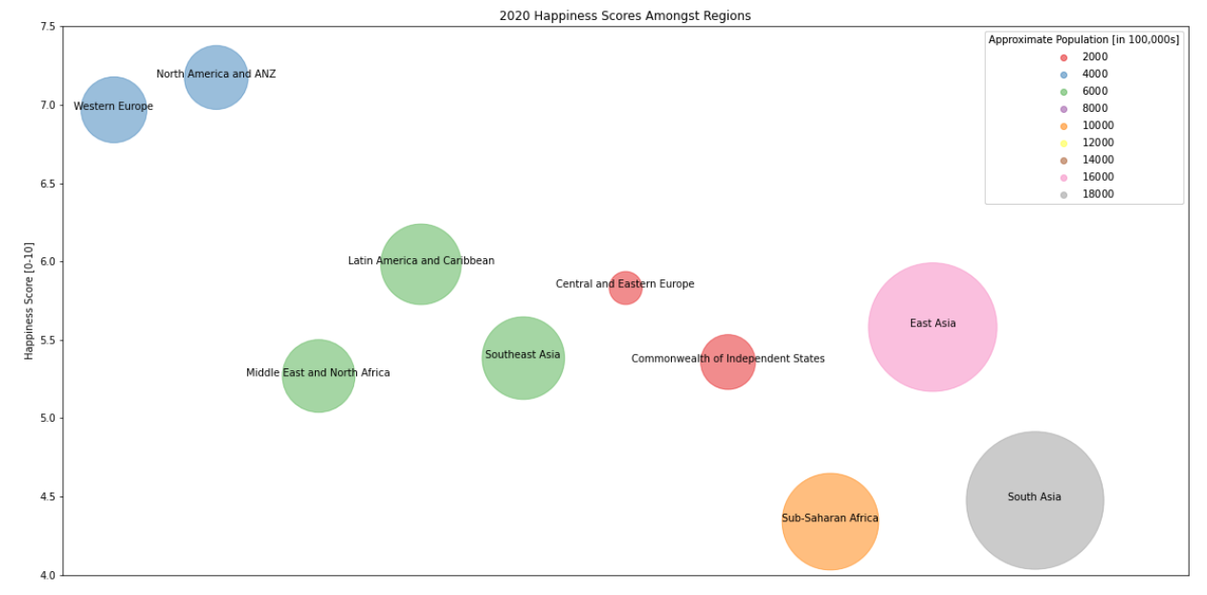

Figure 4 – Bubble plot of the happiness levels amongst the different regions of the world. The higher the bubble for a given region, the higher its associated happiness level. The happiness level for each region is the average happiness level of the countries within that region. The color of the bubble indicates the approximate population for that region, according to the legend.

Based on the above bubble plot, the most populated region in the world, South Asia, is also one of the unhappiest regions. And most regions of the world are experiencing happiness levels between 5 and 6.5. Conclusions about the happiness level of most people in the world are limited based on Figure 5. For example, if one country with a large population, such as China, has an exceptionally low happiness score, and the rest of the lower populated countries within the East Asia region have high happiness scores, the average happiness score would still be high, and the bubble would appear large. This would look as though a much larger amount of people are experiencing a greater level of happiness than is truly the case.

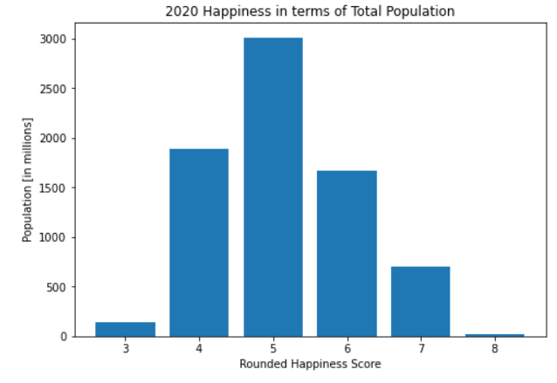

Figure 5 – Bar graph of population of people per happiness level for the year 2020. The happiness score for each country was rounded to its closest integer. The population for each country was then grouped/summed based on its rounded happiness score.

According to Figure 5, most of the world is experiencing a happiness level of around a four or five, with a large amount of people experiencing a happiness level around a six. A small portion of the world is experiencing a happiness level of around an eight. Fortunately, only a small portion of the world is experiencing a happiness level of around a three. This assumes, as before, that the sampled data from the 2020 World Happiness Report is representative of the entire population.

1. Conclusion

Based on my analysis, it seems as though in the year 2020 most people in the world would rate their happiness between a four and six on a scale from one to ten. And that this is likely the case for every year since 2015 given that happiness scores amongst countries has not varied much since 2015. It also seems entirely possible for people to generally feel a happiness level of seven, since there are several countries consistently scoring this high over the years. This begs the question: what can we do to get the happiness scores to increase where it would have the most impact (in countries with the highest populations)? Also, while the happiness score for most countries has remained steady, continued review of the possible causes behind even small trends may help with identifying contributing factors to people’s happiness.



Table 1 – Happiness scores for Greece from years 2015 to 2020.

For example, according to Table 1, happiness scores for Greece have gradually increased since 2015. This is thought to be in line with Greece’s economic recovery since its financial crisis that began in 2009 [1]. Lastly, I think it would be interesting to see how suicide rates correspond to happiness scores, and to know what the contributing factors to high suicide rates are. Curiously, Finland, which had the highest happiness score in the 2019 World Happiness Report, has a relatively high suicide rate [6]. One theory to explain this paradox is that a wide inequality gap exists in Finland [6].

References

[1] Helliwell, J. F., Layard, R., Sachs, J. D., & De Neve, J. (Eds.). (2021). World Happiness

Report 2020. Sustainable Development Solutions Network. https://happiness- report.s3.amazonaws.com/2020/WHR20.pdf

[2] Mullen, T. (2018, June 7). Why Bhutan Is Still Out Of This World. Forbes.

<https://www.forbes.com/sites/tmullen/2018/02/27/why-bhutan-is-still-out-of-this->

world/?sh=28c6c8cc44be

[3] Gallup. (2019, February 14). How Does the Gallup World Poll Work? Gallup.Com.

https://www.gallup.com/178667/gallup-world-poll-work.aspx

[4] FAQ | The World Happiness Report. (2021). World Happiness Report.

<https://worldhappiness.report/faq/>

[5] Bhutan’s Gross National Happiness Index | OPHI. (2021). OPHI Oxford Poverty & Human

Development Initiative. <https://ophi.org.uk/policy/gross-national->

happiness%20index/#:%7E:text=Bhutan%20and%20the%20UN%20Resolution,

promoting%20sustainable%20happine%20%20ss%20and%20wellbeing

[6] Fottrell, Q. (2020, February 2). The No. 1 ‘happiest country’ in the world also has one of the

highest suicide rates — economists have a theory why. MarketWatch.

<https://www.marketwatch.com/story/people-reach-their-lowest-depth-of-misery-at-50-but->

life-improves-after-that-heres-why-2020-01-13